Energy Explorations Outline
Station 7

Electric Circuit Station

Materials:

Energy Batons Samples of insulators & conductors

Bulb holders & light bulbs Switch

Battery holders D batteries

Wire leads

I. Introductions

II. Review of Important Ideas

- Electricity is simply moving electrons.
- Atoms are the building blocks of the universe. Electrons are tiny particles found in atoms.
- The center of an atom is called the nucleus, made of particles called protons and neutrons.
- Electrons are constantly spinning and moving in orbits around the nucleus.

- Circuits
- Electrons flowing through a wire make a complete path, called a circuit.
- A battery produces electricity – moving electrons – only when it is part of a circuit.
- When a switch is open no electricity flows because the path is not complete.
- Different materials are “conductors” of electricity. They allow electrons to travel in a circuit. Some materials do not conduct electricity. They are called insulators.
- Circuits are often described as either series or parallel.

III. Activities

- Energy Baton
- Form a circle and hold the hand or wrist of the people beside you. Two people will each hold one end of the Energy Baton. The baton will light up and make a sound when everyone is touching.
- This represents a closed circuit - everyone is touching allowing a pathway for the electrons to flow.
- Two people release their hands – This represents a switch. The baton will not light up or make sounds. This is an open circuit.
- Allow different pairs of students to act as the switch by opening and closing the circuit. Explain that this represents a series circuit.

- Conductors of Electricity
Electric conductors allow electrons to easily flow. Electric insulators resist or prevent the flow of electricity. Test the following eight materials (paper, coin, foil, wood, plastic, glass, key, paper clip) by placing each item between two students (use students in the circle that are opposite of the baton). The material is a conductor of electricity it will complete the circuit and the bulb will light.
Use the cards to keep track of which materials are electrical conductors and which are electrical insulators. Discuss what the conductors of electricity have in common. (They are all metals.)
Also, point out that conductors and insulators of electricity and conductors and insulators of heat are different.

Conductors: key, coin, foil, paper clip
Insulators: paper, wood, glass, plastic

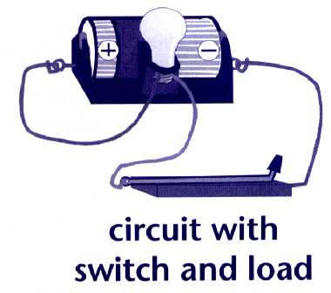
- Circuit with Load – A “load” is anything that uses electricity and offers resistance. In our circuit, this is a lamp. Using the magnetic leads, connect the battery pack to the lamp. Do not allow the lamp to remain on for more than a few seconds to avoid draining the battery.

- Circuit with Load and Switch – Using your circuit above, now add a switch.
By pushing the switch down, you are closing the circuit.

- Series Circuit – Add another lamp to the circuit (see diagram at left). Close the switch to complete the circuit. Do you notice anything different? The bulbs will glow more dimly. What happens if you unscrew one of the bulbs? The other bulb will go out. By unscrewing the bulb, you have opened the circuit and electrons cannot flow to the second bulb.

- Parallel Circuit-Now build a parallel circuit. (see diagram at right.) What do you notice about the intensity of the light bulbs when you complete the circuit? They should both be bright. Now what happens when you unscrew one of the bulbs. The other light stays on. Think about the lights in your house. Do you think they are wired in series or parallel? Why? Parallel-otherwise, so if you turn off one light, they won’t all go out.

- Series & Parallel Circuits with the Energy Baton-If time allows, use two Energy Batons and your group to create a series and parallel circuit. Start with series. (Remember the batons have a +/- ends, so if it isn’t working flip one of the batons around.)

IV. Closing

Attach one wire from the battery clip to the light bulb stand. Attach the wire from the switch to the light bulb stand.
- Fill in booklet or worksheet
- Farewells
- Straighten up and re-set station

Question(s) in student booklet:

The flow of electrons is called ____ELECTRICITY_____ .

Electrons flow through a wire making a complete path, called a ___CIRCUIT________.

