Name: ____________________________________________ Date: ____________________

Sound Shakers Lab Sheet

Introduction:
Sound is energy vibrating through a substance (solid, liquid or gas.) All sounds are caused by vibrations. Remember the dancing pepper on the plastic stretched over a can? Using the tuning fork, you were able the see the sound vibrations.

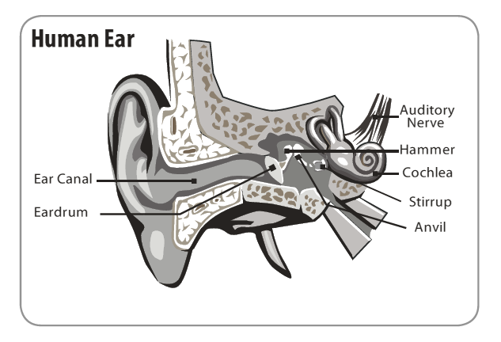
Our ears are amazing organs that change sound waves into electrical signals and then send them to our brains. Sound waves enter the ear canal and travel back to the eardrum. The eardrum is a thin layer of skin that is stretched tightly over the end of the ear canal, much like the skin of a drum, or the plastic over the metal can. The sound waves transfer their energy to the eardrum, which begins to vibrate.
NEED EnergyWorks Student Guide page 52

Procedure:
You are going to make some vibrations that will vibrate on your ear drum. There are eight mystery containers. You will repeat this activity twice.
- Shake each container. What do you think is in the container? Write it on the line next to the number in Chart #1.
- Now your teacher will give you a list of the items in the containers. Shake the containers again. Now that you have a list of the container items, match the sound with the container number in Chart #2.

 | Chart 1
Container | Mystery Item
1
2
3
4
5
6
7
8

 | Chart 2
Container | Mystery Item
1
2
3
4
5
6
7
8

