What is Energy? 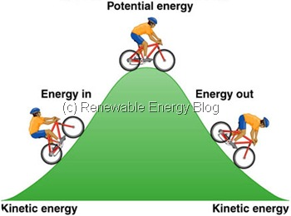
Name ____________________________________________
You should be in a group with 3 to 4 partners,
In the box below, brainstorm ideas to complete this sentence. Energy is……
Your answers.

Class answers.
The ability to cause a change in an object or the ability to do work.

Energy can be divided into two categories:
Potential energy is: (your definition) | Kinetic energy is: (your definition)
Potential energy is: (class definition) | Kinetic energy is: (class definition)
Stored energy and energy of position (gravitational) | Energy of motion: Can be motion of waves, electrons,
It is waiting to be used. | atoms, molecules and substances.

Observe the demonstration of the animal slingshot. Describe it below in terms of kinetic and potential energy.
As the rubber bands are pulled back, that is the stored / potential energy. The greater the stretch of the band, the greater the potential energy contained in the object. When the animal is released, the potential energy is changed to kinetic energy and the animal flies across the room. It will fly until the force of gravity and the friction of the air become greater than the energy in the system.

Your teacher will demonstrate some materials.
In the table below, list the object in the box that best describes the category of energy used.
POTENTIAL  battery  granola bar/ food  glow stick  lighter  slinky | BOTH  Battery powered toy  Push/pull toy  Hand warmer  Yo-yo  Bouncy ball  slinky | KINETIC  Glow stick activated  Lighter (on)

EXTENSION: For homework, find one example of potential energy and show how it can be changed to kinetic energy. Be prepared to share this example with classmates on the following day.

