Energy Explorations Outline
Station 7

Electric Circuit Station

Materials:

Energy Batons Samples of insulators, conductors and chart

Bulb holders & light bulbs Switch, Wire Leads

Battery holders & D Batteries Atom Diagram

Introduction to Electricity:

At this station we are exploring electricity. First we need a little background information:
- What is all matter made of? (atoms) Atom are tiny particles that you can’t see.
- Show Atom Diagram. The center of an atom is called the nucleus. It is made of particles called protons and neutrons.
- Electrons are constantly spinning and moving in orbits around the nucleus.
- Electricity is moving electrons.

Activity #1: Energy Baton & Circuits
- Electricity flows through a wire in a complete path called a CIRCUIT. Show students Energy Baton without touching both ends. The baton has a battery, lights and sound maker. For electricity to flow, the electrons must flow from one silver band to the other. Right now, is my Energy Baton circuit open or closed? It is open because there is not a complete path for the electrons.
- Hold both ends of the Energy Baton. Now is the circuit open or closed? It is closed. I’m part of the circuit. The electricity is flowing across my skin.
- What would we need to do to make our whole group a circuit? Form a circle and touch the finger of the people beside you. Two people will each hold one end of the Energy Baton. This represents a CLOSED CIRCUIT. Everyone is touching allowing a pathway for the electrons to flow.
- Have two people release their touch. These students represent a SWITCH. A switch allows a circuit to be opened and closed. We now have an OPEN CIRCUIT. Allow different pairs of students the chance to be the switch.

Activity #2: Energy Baton & Electricity Conductors and Insulators
Note to Leaders: Using the same set up with your group as in Activity #1, test each sample of a conductor or insulator buy having two students hold one end of each item. Engage your entire group in the activity.
- Next we are exploring electric conductors and insulators. Any ideas what a conductor is? A CONDUCTOR allows electrons to easily flow. So what is an electric insulator? An INSULATOR resists or prevents the flow of electricity.
- We’re going to test different materials to determine if they are insulators or conductors. Let’s first predict if we think the material is an insulator or conductor.
  - Ask students to predict if the material is an insulator or conductor.
  - Test the material by placing it in the circuit with two students holding one end of each material.
  - Conductors will allow the Energy Baton to light up. Insulators will resist the flow of electricity keeping the circuit open and not lighting up the Energy Baton.
  - After testing the material, put it on the chart as an insulator or conductor.
  - Repeat the process for all eight materials. What do the conductors have in common? All are metal
Conductors: key, coin, foil, paper clip
Insulators: paper, wood, glass, plastic

Activity #3: Building Circuits
Note to Leaders: This activity may be more challenging for your groups. Your role is to help facilitate building circuits and to troubleshoot if a circuit is not working. Allow the elementary students the opportunity to build the circuits. Try not to build the circuits for them.
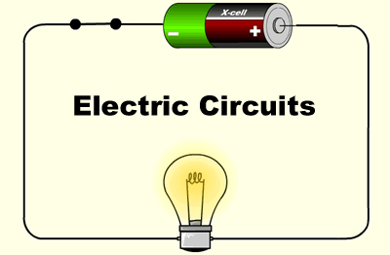
Circuit with Load: A LOAD is anything that uses electricity and offers resistance. In our circuit, the load is a lamp. Using the magnetic leads, connect the battery pack to the lamp. Do not allow the lamp to remain on for more than a few seconds to avoid draining the battery.
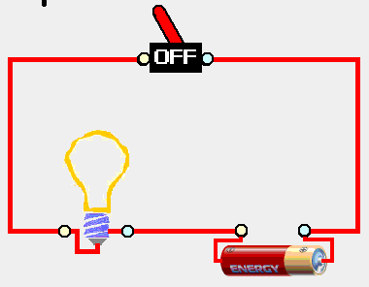
Circuit with Load and Switch: Using your circuit with a load, add a switch. The switch allows us to easily open and close the circuit.
- Show me a closed circuit. Push the switch down. The light will be on.
- Show me an open circuit. Pull the switch up. The light will be off.

Circuits in Series & Parallel
Circuits can have more than one load. Think of a string of Christmas lights. There are 100 lights wired together. Circuits with many loads can be described as series or parallel. A SERIES CIRCUIT has only one path for the electricity to flow. A PARALLEL CIRCUIT has more than one path for the electricity to flow.

Series Circuit: Replace the switch from the last circuit with a second light bulb. Do you notice anything different? The bulbs will glow more dimly. What happens if you unscrew one of the bulbs? Why? The other bulb will go out. By unscrewing the bulb, you have opened the circuit and electrons cannot flow to the second bulb

Parallel Circuit: Using the same parts from the series circuit plus a couple extra wires, build a parallel circuit. What do you notice about the intensity of the light bulbs when you complete the circuit? They should both be bright. Now what happens when you unscrew one of the bulbs. The other light stays on. Think about the lights in your house. Do you think they are wired in series or parallel? Why? Parallel. Otherwise, if you turn off one light, they would all go out.

Complete Student Worksheet Questions:
Note to Leaders: Ask these questions to the students. Do not just give them the answer. If incorrect answers are given, talk the students through the correct answer. You may need to refer back to the definition.

Electrons flow through a wire making a complete path. What is that path called? CIRCUIT

What is an example of an electricity conductor? MANY CORRECT ANSWERS: ANYTHING METAL, WATER

