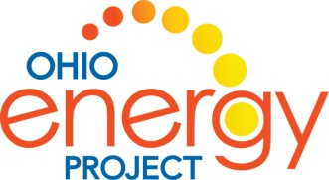

PRE~~PRE~~PRE~~PRE~~PRE~~PRE~~PRE~~PRE~~PRE

Answer the questions to the best of your ability by CIRCLING the best answer.

1. The bending of light as it passes from one medium to another is called ____________.

a. reflection b. detection c. refraction d. investigation

2. Thermal energy flows from ________ to _______ until a balance is reached.

a. cold to cold b. cold to hot c. hot to hot d. hot to cold

3. The frequency of a sound wave is called its _____________.

a. pitch b. vibration c. catch d. soprano

4. Sound waves travel best in a _______________.

a. gas b. liquid c. solid d. vacuum

5. All of the following are good thermal insulators EXCEPT ________________.

a. pot holder b. carpet c. metal pot d. winter coat

6. A pathway for electricity to follow is called a ___________.

a. road b. circuit c. vibration d. pattern

7. The motion of an object depends on force and _______________.

a. length b. height c. mass d. structure

8. Pedaling a bike is an example of ______________ energy.

a. electrical b. radiant c. chemical d. mechanical

9. Light always travels in a ________________ line.

a. circular b. curvy c. straight d. zigzag

10. A ______________ is a good conductor of electricity.

a. metal spoon b. plastic spoon c. straw d. piece of paper

