Energy Chants
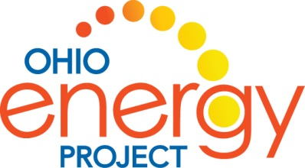

For a video to review the Energy Chants and hand motions, search YouTube for “NEED Energy Chants”

Nonrenewable Energy Sources

Coal Chant: Workin’ in a coal mine, ugh hard hat.

Pretend like you’re holding a shovel and dig into the ground while saying, “Workin’ in a coal mine”, then pull the shovel up and over your shoulder giving a loud grunt and then say “Hard hat”!

Nuclear Chant: Uranium, Uranium – split goes the atom!

Knock fists together during “uranium, uranium.” During “split goes the atom,” clap and bring hands up and out, representing splitting of the atom.

Propane Chant: Compress, compress, compress, Proooooo-pane!

With your arms in front, elbows bent, fingers spread open, move your hands together as if you’re pushing in, while saying “compress, compress, compress.” Then fingers together, start moving your arms in a wave motion as you’re saying “prooooo-pane.”

Natural Gas Chant: Burn clean, burn fast, NATURAL GAS!

During “burn clean,” bring one had up in front of you palm facing inward. During “burn fast,” bring the other hand up to the first hand. During natural gas,” move hands upward to make the shape of a diamond or a flame.

Petroleum Chant: Blurb, blurb, PETROLEUM!

Place hands together in fists in front of you. During “blurb, blurb,” partially extend fingers and then return them to your fist. During “petroleum,” fully extend hands and move them upward, representing oil shooting out of a well.

Renewable Energy Chants

Wind Chant: I’ll huff and I’ll puff, and I’ll blow the turbines!

Holding your arms above your head, start spinning your arms around like a windmill and say “I’ll huff and I’ll puff and I’ll blow the turbines”!

Solar Chant: S, O, L, A, R, Solar, zzz, it’s hot!

Clap the letters to S—O—L—A—R—and then shout solar and put your thumb to your lips and make a sizzling sound, then to your hip and say – “it’s hot”!

Hydropower Chant: Falling water, hydropower, hydpropower!

With your finger tips touching, hold your hand under your chin and glide your hands down like a waterfall during “falling water.” For hydropower, spin your hands like a turbine.

Geothermal Chant: g…g…g…g… geo- thermal!

From a squatting position, like you’re bringing up geothermal energy out of the ground, put your hands together and as you’re rising up, g…g…g…g… geothermal and when you say geothermal, spread your arms apart as if from geyser and the energy is exploding out of it.

Biomass Chant: Garbage, wood, landfill gas – it’s all BIOMASS!

Start with our hands down, then move them over your head and out like a tree while you say “Garbage, wood, landfill gas – it’s all BIOMASS”!

