Name: ____________________________ School: ____________________________

Fuel Cell & Energy Transformations Workshop

The Law of Conservation of Energy says:

- Energy cannot be _______________________________ or ____________________________; it only changes ___________________________.

 | Form of Energy | Example of Energy Form
N
C
M
E
R
T

- Write the energy transformation equation for the no-battery-flashlight:

→ → + +

- What is a fuel cell?

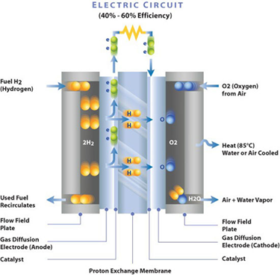
Courtesy of Ballard Power

- What are some advantages of fuel cells?

- Where are fuel cells currently in use? How could they possibly be used in the future?

- What are some challenges of fuel cells?

- Write the energy transformation equation for the fuel cell car:

