Name ________________________________ Date ______________
Save the Penguins
Lesson 3
Background: The average temperature of the Earth has risen over the last 100 years. Evidence has shown that the amount of ice at both poles has decreased. Penguins must have cold temperatures to survive and raise their chicks.

Challenge: You will use your knowledge of thermal energy to design, build and test a dwelling that keeps a penguin shaped ice cube from melting.

Requirements:
- Your dwelling must be 10 cm by 10 cm by 10 cm or smaller.
- Your penguin ice cube must be placed in a plastic cup with a lid and placed in the dwelling.
- The dwelling must have an opening for the penguin to easily enter and leave the dwelling. It cannot be taped shut.
- What is the problem? (State the problem in your own words.)
___________________________________________________________________________

___________________________________________________________________________

___________________________________________________________________________

- Brainstorm some possible designs. Remember to ask your team the following questions.

- What materials will be a good insulator?
- What are some design features that keep your house cool in the summer?
- What color clothes are the coolest in the summer?
- How many layers of material will you use?
- Is air a good conductor or insulator?
- Could light get into your penguin dwelling and melt the penguin?
- How will you get your penguin in and out easily?

- Draw your possible designs.

Circle the one you will build. Remember, you can test your design and make changes.
- Why did you choose this design? ______________________________________________________________________________
______________________________________________________________________________

Make a list of the materials you will use for your dwelling? Who will bring the material into school?
Materials | Who will bring it to school?

- Build your designed penguin dwelling.
- Make a labeled diagram of your final completed penguin dwelling. Include the measurements.

Testing: Use the balance to take your penguin’s measurements.

PRE-TESTING MEASUREMENTS: Table 1

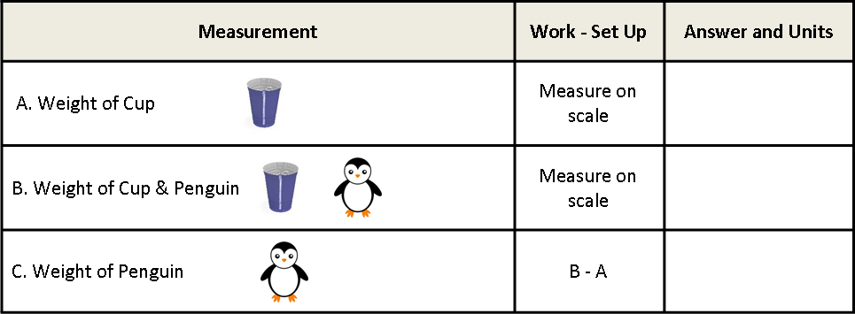

- Place the penguin in the cup and place it inside the dwelling. Place the dwelling on the counter, in sunlight or under a heat lamp, for 30 minutes.

POST-TESTING MEASUREMENTS: Table 2

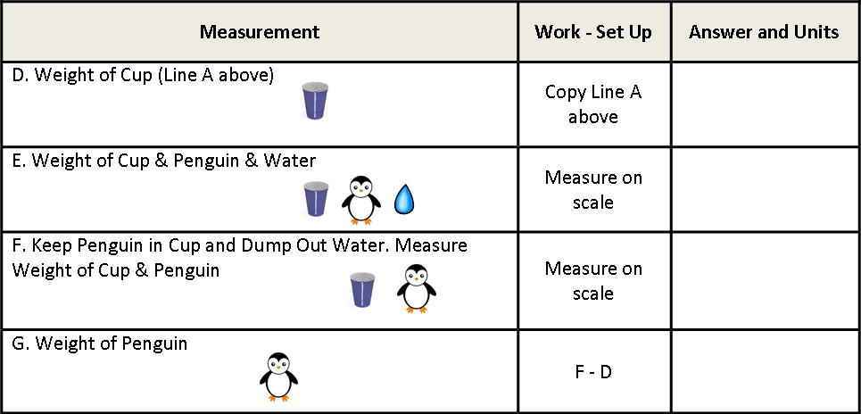

- Compare the weight of the cup & penguin (Line B) in the Pre-Test to the weight of the cup & penguin & the water (Line E) in the Post-Test. Explain how your results support the conservation of matter.

__________________________________________________________________________________________________________________________________________________________________
- OPTIONAL EXTENSION: To determine which dwellings had the best insulation, calculate the percentage of weight loss between the penguin in the Pre-Test (Line C) vs. the weight of the penguin in the Post-Test (Line G). The group with the lowest percentage of weight lost had the best insulated dwelling.

$$Percent Weight Loss=\frac{\left(C-G\right)}{C} ×100\%$$

Analyze Results
- What design features were most effective in reducing heat transfer? _____________________
_____________________________________________________________________________
- How would you change your design to prevent more heat transfer? _____________________
___________________________________________________________________________
___________________________________________________________________________
- How does saving energy at home help animals that live so very far away? ________________
___________________________________________________________________________
- What science concepts did you have to know to design a successful penguin dwelling? ______
___________________________________________________________________________
___________________________________________________________________________
- Why is it important to do a redesign? _____________________________________________
___________________________________________________________________________
- Describe how heat energy moves. _______________________________________________
___________________________________________________________________________

Thanks for your help!
Keep saving energy and stay cool!

