Light Reflection
Teacher Lesson Plan
Background Information

Light is energy that travels in waves.
- Light travels in straight paths until it hits an object.
- If light hits the surface of a medium that is smooth and polished, the wave will bounce back or be reflected.
- A wave that strikes the surface of an object is called the incoming or incident ray and the one that bounces back is the reflected ray.
- The reflected ray will be reflected back at the same angle as the incoming/incident ray. This is known as the Law of Reflection.

Content Standards
- Physical Science
- Light and sound are forms of energy that behave in predictable ways.

Student Activities – Light Reflection

LESSON 1: Can You See Me Now?

Lesson Materials:
- 4 inch square mirror (tape edges to prevent injuries)
- Masking tape (to hold mirror to wall)
- 4 inch square paper or post it note
- Protractor with hole for drawing circles
- 10 feet of string

Procedure:
- Students will work with one or two partners for this activity.
- Double tape mirror on the wall at student eye level. Cover the mirror with the post it on top so you can lift it to see the mirror.
- Tape a 5 foot line on the floor perpendicular to the wall directly under the mirror.
- Thread the string through the hole in the protractor.
- Tape the protractor to the floor so the ruler part is next to the wall with the 90⁰ mark on the
center of the masking tape. Be sure to be able to adjust the string so that half of it is on each side. The tape represents the “normal” in this set up.

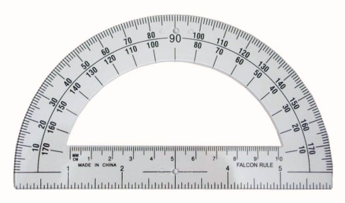
Tape
wall
This hole

- An alternative would be to tape the straight edge of the protractor to the wall with the 90⁰ mark directly under the middle of the mirror.
- Both you and your partner need to hypothesize where to stand to see each other’s reflection in the mirror. When you agree on the places, mark them on the floor with a small (3 inch) piece of masking tape.
- Remove the paper from the mirror. Stand at your spot and check if you can see your partner.
- If you cannot see your partner’s eyes, move your spot. When you can see each other’s eyes, adjust the tape on the floor.
- Each partner now should gently pull the string so it goes from the protractor to your spot that you marked on the floor.
- Measure the angles made by the string. Remember to measure each side from the zero mark.
- Repeat the activity again. Cover the mirror and stand at a different angle.

Student Discussion Questions:
- How do the angle measurements compare? The angle measurements are equal. If the angles are slightly off, what may attribute to that situation? Answers will vary but may include: Students can be different heights, the string may not be directly under the zero mark on the protractor or you are “eyeballing” the angle and may be slightly off.
- Explain how light is reflected off a mirror? If an object does not emit light on its own, it must reflect light in order to be seen. Reflection involves two rays – an incoming or incident ray and an outgoing or reflected ray. The Law of Reflections requires that the two rays are at identical angles but on opposite sides of the normal – the perpendicular imaginary line at right angles to the mirror.
- Describe two real life situations where this can be used. They can be used in car back up mirrors, in drive thru windows at fast food restaurants, fiber optics, and periscopes.
- Draw a diagram with lines showing how light is reflected off a mirror.
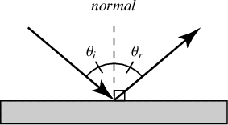
LESSON 2: Laser Maze Jr.

Lesson Materials:
- Laser Maze activity box
- AAA batteries are included, but you will need to install them prior to using the kits for the first time.

Procedure:
- Students will use the Law of Reflection to solve puzzles.
- The goal for each challenge is to light up all of the rocket targets by correctly placing the satellite mirrors and beam splitters around the grid.
- Students should begin with the “easy” puzzles first then progress to more difficult challenges with blockages and multiple steps.

