What Are Lenses?

What are lenses?
A lens is a transparent piece of glass or plastic with at least one curved surface. It gets its name from the Latin word for "lentil" (a type of pulse used in cooking), but don't let that confuse you. There's no real reason for this other than that the most common kind of lens (called a convex lens) looks very much like a lentil! Lentils gave lenses their name. Convex lenses bulge out in the middle like lentils, while concave lenses "cave in" in the middle and bulge out at the edges.

How do lenses work?
A lens works by refraction: it bends light rays as they pass through it so they change direction. That means the rays seem to come from a point that's closer or further away from where they actually originate—and that's what makes objects seen through a lens seem either bigger or smaller than they really are.

Types of lenses
There are two main types of lenses, known as convex (or converging) and concave (or diverging).

Convex lenses
In a convex lens (sometimes called a positive lens), the glass (or plastic) surfaces bulge outwards in the center giving the classic lentil-like shape. A convex lens is also called a converging lens because it makes parallel light rays passing through it bend inward and meet (converge) at a spot just beyond the lens known as the focal point.

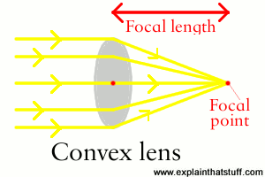

Convex lenses are used in things like telescopes and binoculars to bring distant light rays to a focus in your eyes.

Concave lenses
A concave lens is exactly the opposite with the outer surfaces curving inward, so it makes parallel light rays curve outward or diverge. That's why concave lenses are sometimes called diverging lenses. (One easy way to remember the difference between concave and convex lenses is to think of concave lenses caving inwards.)
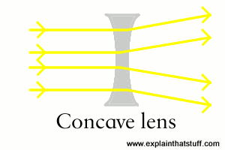

Concave lenses are used in things like TV projectors to make light rays spread out into the distance. In a flashlight, it's easier to do this job with a mirror, which usually weighs much less than a lens and is cheaper to manufacture as well.

