The Wave Exercise
Teacher Lesson Plan

Background Information
This exercise is designed to create a kinesthetic learning activity for students to understand wave theory. In it, the students themselves model waves.
- A wave is the transfer of energy through space or matter.
- Light waves travel as transverse waves in empty space in a straight line. It travels at a speed of 186,000 miles per second. Compared to sound, light travels extremely fast. It takes less than 8 ½ minutes for light from the sun to reach the Earth which is 93,000,000 miles away.
- Sound waves need a medium in which to move by transferring the energy from one particle of matter to the next. The medium in which the wave is traveling does not move but the energy does.
- The speed of sound depends on the type of medium in which the energy is traveling. Sound travels fastest in solids, medium speed in liquids and slowest in gases. The temperature of the medium also effects the speed of the sound waves with the energy transferred fastest in high temperatures and slower at lower temperatures.
- Waves are characterized by their wavelength, frequency and amplitude.
- Wavelength – is the distance between two corresponding points between neighboring waves. This is typically crest to crest or trough to trough. Wavelength determines the type of light based on the electromagnetic spectrum.
- Frequency is the number of waves passing a given point every second. Frequency and wavelength determine to the pitch in sound. Different frequencies in visible light waves produce different colors.
- Amplitude refers to the height of a wave. In light, it refers to the intensity or brightness of the wave. In sound, it refers to the volume or loudness.
- There are two types of waves.
- Transverse - in these waves, the displacement of the particles is perpendicular to the direction of the propagation of the wave. A ripple on a pond and shaking a rope are examples of transverse waves. Light waves are another example of transverse waves.
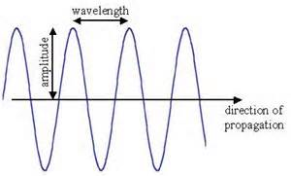
- In longitudinal waves the displacement of the medium is parallel to the propagation of the wave. These are also called compression waves. A wave in a "slinky" is a good visualization. Sound waves are longitudinal waves.

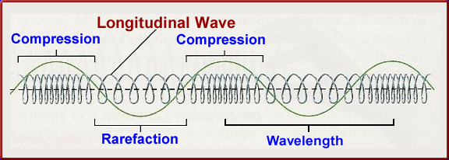

Content Standards
- Physical Science
- Light and sound are forms of energy that behave in predictable ways.

Student Activities

LESSON 1: The Wave Exercise

Lesson Materials: none required

Activity #1 Human Wave Procedure:
- Together we will do “The Wave” like you have seen people do in stadiums.
- Line up shoulder to shoulder. Placing toes on a line on the floor is helpful.
- You move ONLY after the person to your left moves.
- Keep your feet in the SAME PLACE. They should be stuck. Students are the particles in the medium. Students don’t travel but the energy moves through them.
- The teacher should start the “The Wave”. Every wave needs an energy source. The teacher is the source.
Student Discussion Questions:
- What is the definition of a wave? A wave is the transfer of energy from one place to another. The students stay in place but the energy moves down the line.
- Where did the energy come from? The teacher generated the energy to start the wave.

Activity #2 Amplitude Procedure:
- Next, we will repeat our wave but just move our hands a few inches up and down. This represents a whisper.
- Repeat, but only move our arms up and down. This represents talking.
- Repeat, but move your whole body up and down. Remember, your feet stay in place. This represents shouting.
Student Discussion Questions:
- What is changing in the wave? The wave height is changing.
- What is the name of this wave characteristic? Wave amplitude. It is measured from the centerline of the wave to the highest or lowest point.
- Challenge: Do a small amplitude wave. Do a large amplitude wave.
- In a sound wave, what characteristic does amplitude represent? It represents the loudness or softness of the sound.

Activity #3 Transverse & Longitudinal Waves Procedure:
- Notice that all waves done so far have all moved up and down and are called TRANSVERSE waves. The particles move perpendicular to the direction that the energy travels.
- Waves also move parallel to the direction of the energy. These are called LONGITUDINAL waves. Sound waves are longitudinal waves.
- Everyone is lined up shoulder to shoulder and pass a hand squeeze down the line.

Activity #4 Wave Speed Procedure:
- Adjust your line so that the students are arm’s length apart. The teacher should generate a longitudinal wave by gently pushing on a student’s shoulder. Describe the speed of the wave with the large space between the students.
- Adjust your line so that the students are half the distance apart. The teacher should generate a longitudinal wave. Describe the speed of the wave with this space between the students.
- Adjust your line so that the students’ shoulders are touching. The teacher should generate a longitudinal wave. Describe the speed of the wave in this demonstration.

Activity #5 Wave Reflection Procedure:
- Students MUST keep their feet in the same place. Stand shoulder to shoulder. The teacher should pass a gentle shoulder push down the line. Repeat one more time but the student at the end of the line should pass the impulse back to the person next to him. It should travel until it gets to the first person in the line. This represents a wave reflection.
Student Discussion Questions:
- Discussion - Waves move at different speeds through different kinds of matter. Matter that is solid has particles packed tightly together so the energy moves fastest through the solids. In a gas, the particles are farther apart from each other so it would take longer to pass the energy. Liquids represent the middle speed.
- Which of the wave demonstrations would represent a solid? The fast wave
- Which of the wave demonstrations would represent a gas? The slowest wave
- You are scuba diving and hear the song of a humpback whale. Who would hear it first, the captain of your dive boat or you in the water? The scuba diver would hear it before the boat captain. Why? Sound waves travel faster in liquids than they do in a gas.

