Electricity Pre/Post Test KEY
Name ___________________________________
Choose correct answer.
_____ 1. Which of the following is a Secondary Energy source?
- Coal c. Natural Gas
- Solar d. Electricity
_____ 2. At a coal fueled electricity generation plant, the purpose of burning coal is to:
- To heat water to steam that turns a turbine.
- Apply heat to the conducting wires.
- To heat the conductor creating a magnetic field.
- Provide a source of electrons.
_____3. Current is measured in units called:
- volts c. coulombs
- amperes d. ohms
____4. Which of the following is considered a “load” in a circuit?
- lamp c. motor
- speaker d. all are loads
____ 5. To turn a switch “on”, you ______________ it.
- voltage c. pressurize
- close d. open
____ 6. You have a flashlight with two 1.5 volt batteries wired in series. What is the electrical pressure?
- 1.5 volts c. 3 volts
- 3 amps d. 1.5 ohms

_____7. Which of the following would all be connected in parallel?
- A lamp and a switch on the wall controlling it.
- The streetlamps in your neighborhood.
- A string of holiday lights that all go out if one is loose.
- None of these are connected in parallel.

____8. If there is more than one continuous path for the electrons to flow, that circuit is wired in:
- parallel circuit c. short circuit
- series circuit d. long circuit

____ 9. Which of these is a short circuit?
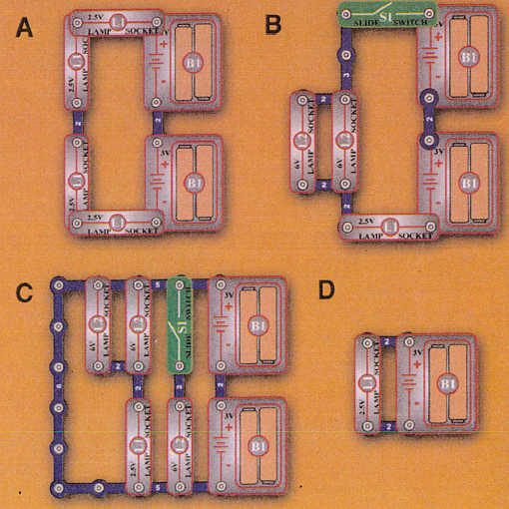
____ 10. Explain what happens when you reverse the polarity in a motor.
- The fan speeds up. c. The fan slows down.
- The fan shuts down. d. The fan changes direction.
____ 11. Which of the following circuits would have the brightest bulb?
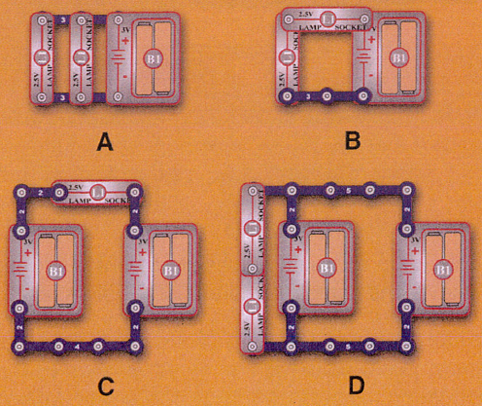
_____ 12. If there is a 1.5V battery and a bulb on a simple series circuit and the battery is changed to
3V, what happens to the bulb?
- gets brighter c. gets dimmer
- gets hotter d. a short circuit occurs
____ 13. Which of the following are sources of voltage?
- generator c. solar panel
- battery d. all of the above
____ 14. Which of the following is true about LED’s?
- They block current flow in one direction.
- LED stands for Low Electron Diode.
- They do not require a resistor in a circuit to work.
- They can only produce white light.
_____ 15. One of the causes of electrical pressure that causes a current to flow is:
- The negative charges of the electrons cause them to repel each other.
- The positive charges in the conductor repels the electrons.
- The conductive material in the wire attracts protons.
- The insulating material blocks the flow of electrons.
_____ 16. What happens when you cover a photoresistor?
- Increase voltage and decrease pressure.
- Increase resistance and increase wattage.
- Decrease current and decrease resistance.
- Increase resistance and decrease current.
_____ 17. In a circuit that has a light dimmer, it most likely is wired with which piece of electronic equipment?
- capacitor c. transistor
- variable resistor d. photoresistor
_____ 18. Placing resistors in _______________ increases the total resistance while placing them in
________________ decreases total resistance.

- parallel; series c. series; parallel
- watt; amperes d. series; ohm
_____ 19. A circuit uses batteries to run a motor with a fan. How could you reduce the speed of the
motor?

- Use more batteries to increase voltage
- Place a lamp in series with the motor to reduce voltage to it
- Remove the fan from the motor
- None of the above

______ 20. Nearly all electricity eventually becomes ____________________.
- information b. wasted c. chemical energy d. thermal energy

