TEACHER KEY
Light & Sound
Snap Circuits

Building Tips for Snap Circuits:
- The plastic base grid, labeled 1 - 10 and A - G, is used to help space the different parts. It functions like a printed circuit board.
- Each part has a different function and label. For example, the green slide switch is marked on the
diagram.
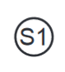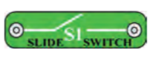
- The blue snap wires connect different parts. They come in different lengths.
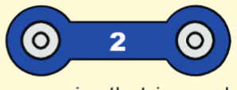
- Next to each part in the circuit drawings is a small placement level number in black. This tells you which level the component is placed. Put all the 1’s down first, then the 2’s, then the 3’s.
- Some parts have a positive (+) and negative (-) side or terminal. When building circuits, take special note of the direction of the +/- sides of the part in the diagram.

Build Project 1: Color Light (page 30)
Attach the different LED attachments on the color LED (D8).
Describe what happens with the tower, egg and fiber optic tree.

The LED comes on and the attachment glows.
Are the egg and tower attachments transparent, opaque or

translucent? Translucent

Explain why. Some light passes through, but it is scattered or diffused.

Turn the LED component around. Does the LED work? No
Explain why or why not. In an LED, electrons only flow in one direction through the circuit.
See page 10 in the Snap Circuit Activity Guide.

Using the same circuit as in Project 1, switch the color LED (D8) with the white LED (D6) following the directions in Project 2. Note any changes. Then replace the white LED (D6) with the red LED (D1) following the direction in Project 3. You may need to turn the room lights off.

What differences did you observe between the color (D8), white (D6) and red (D1) LED’s? The white LED is very bright. The red LED is dim.
Build Project 5: Voice Light Show (page 32)
Place one of the LED attachments (tower, egg, fiber optic tree) over the LED on the color organ (U22). Turn on the switch (S1) and speak into the microphone (X1). Experiment with different sounds and voices.
What happens to the color of the light as you change your pitch and volume? The color changes with the pitch & volume of your voice.
Explain why this happens. The sound waves from your vocal cords are air pressure waves. These waves are changed to electrical pressure waves in the microphone. This is a similar process to what happens in a telephone. In the LED, each color has a different resistance so as the pressure changes, the color changes. It is controlled by an electrical counter in the color organ.
See page 14, 16 and 32 in the Snap Circuit Activity Guide.

Using a phone, play music into the microphone (X1). How is this different from speaking into it? The color changes not only with the pitch and volume of the musician’s voice, but with the background music.

Try a second song. Are the light patterns the same as the first song? No

Why? The pitch and volume are different for each song.

Build Project 16: Color Optics (page 38)

Build the circuits. Do not connect the clear cable. What happens when you turn on the

switch? The colored LED lights up and changes color and speed.

What happens to the right side of the circuit?
Nothing

Connect the clear cable as shown in the diagram and turn on the slide switch (S1). Make sure the cable holders do not bend. What happens?
As the blinking of the LED (D8) changes, the sound changes. The sound pattern matches the changing speed of the blinking LED.

Is there an ELECTRICAL connection between the right side and left side of this circuit? No

What happens to the sound when the LED’s blinking (D8) changes speed? The sound changes speed to match the blinking.

Explain how the sound is produced. The left circuit makes a coded light signal. The right circuit decodes the light signal and plays it on the speaker. The fiber optic cable transmits the light signal between the two circuits. There is no electrical connection. This is an example of how fiber optic cables can be used in communication. A communication cable consists of multiple fiber optics and can be transmitted great distances.
Build Project 105: Funky Light & Sound (page 65)
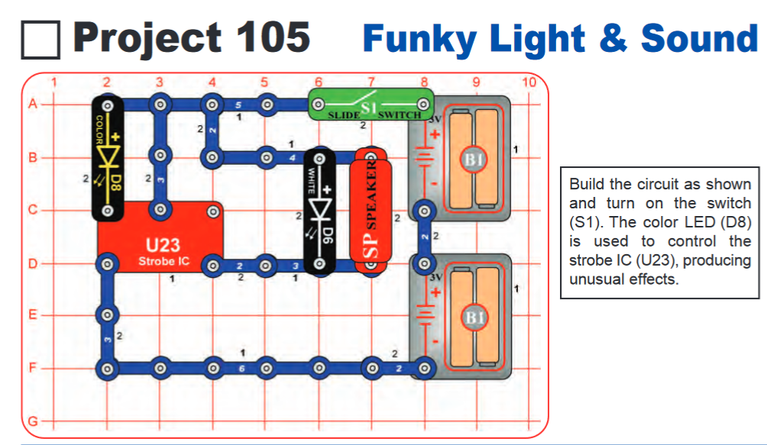
Describe what happens to both light components when the switch is turned on.

The color LED (D8) is on blinking different colors at different speeds. The white LED (D6) is on steady.

Switch the D8 and D6 components in the circuit. What happens?

Both LED’s are one. The white LED (D6) is still on steady. The color LED (D8) is on, but not changing colors or blinking.

Is the light controlling the sound or the sound controlling the light?

Light is controlling the sound.

U23 is a Strobe Integrated Circuit. It contains resistors, capacitors and transistors that are needed to make a strobe light or sound circuit.

Using the same circuit as in Project 105, switch the color LED (D8) with different resistors (R3 and R5) following the directions in Project 106. Note any changes.
Using the same circuit as in Project 106, replace the speaker (SP2) with the motor and fan (M1) following the directions in Project 107. Note any changes.

Build Activity 108: Adjustable Light & Sound (page 65)
Start with the lever on the adjustable resister (RV) in the middle. Turn on the switch (S1). Describe what happens when you move the lever on the adjustable resistor (RV) to the left and to the right.

The pitch and volume change.

Why does this happen?

The resistance is changing within the circuit.

Using the same circuit as in Project 108, replace the speaker (SP2) with the motor and fan (M1) following the directions in Project 109. Note any changes.

EXTENSION-Build Activity 190: Voice Recorder & Changer (page 96)
Follow the directions for recording your voice.
- Set the adjustable resistor (RV3) to midrange. The arrow should be pointing to the bottom of the part.
- Begin with both slide switches (S1) turned OFF. Be sure to turn switches on and off in the correct sequence.
- Turn ON the RIGHT slide switch (S1).
- Turn ON the LEFT slide switch (S1). You will hear a beep.
- Speak into the microphone (X1). When you hear three beeps, the recording has ended. It will record for about 6 seconds.
- Turn OFF the LEFT slide switch. Leave the RIGHT slide switch ON.
- PUSH the press switch (S2) to play. You will hear your recording.
- Turning the knob on the adjustable resistor (RV3) changes the playback speed which will change the voice recording. Turn to the right to speed up your recording. Turn to the left to slow down your recording.

EXTENSION-Build Activity 184: Electronic Keyboard (page 93)
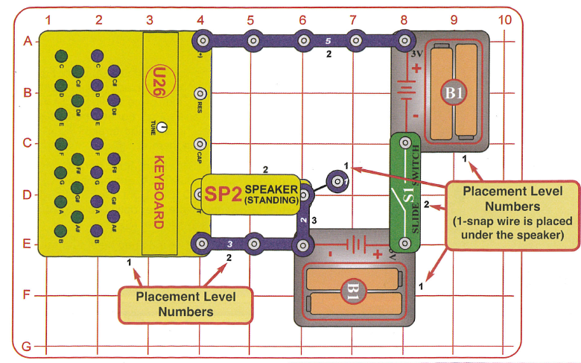
See page 94 in the Project Manual to play different simple songs on the keyboard.

