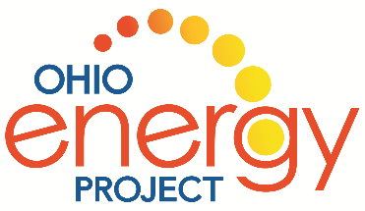

Welcome to Energy Jeopardy

The goal of Energy Jeopardy is….

To work as a TEAM to answer as many questions in energy categories as fast as you can. This game is modeled after the popular game show Jeopardy.

SET UP: Game board, game markers and energy questions on the table.

DIRECTIONS:

- Pick an energy category and a dollar amount and I will give your team the first answer.

- Your team must give me the correct question. I’ll cover each dollar amount with a game marker.

- After 15 seconds, you can pass and move onto the next question.

Note to Leaders:
Be excellent clue givers and encourage teamwork with all kids involved in the game.

ANY QUESTIONS?

