Energy Explorations Outline
Station 2

Electric Circuit Station

Materials:

Energy Batons Atom Diagram Samples of insulators, conductors and chart

Introduction to Electricity:

At this station we are exploring electricity. First we need a little background information:
- What is all matter made of? (atoms) Atom are tiny particles that you can’t see.
- Show Atom Diagram. The center of an atom is called the nucleus. It is made of particles called protons and neutrons.
- Electrons are constantly spinning and moving in orbits around the nucleus.
- Electricity is moving electrons.
- Protons have a positive charge, electrons have a negative charge and neutrons have no charge.

Activity #1: Energy Open & Closed Circuits
- Electricity flows through a wire in a complete path called a CIRCUIT. Show students Energy Baton without touching both ends. The baton has a battery, lights and sound maker. For electricity to flow, the electrons must flow from one silver band to the other. Right now, is my Energy Baton circuit open or closed? It is open because there is not a complete path for the electrons.
- Hold both ends of the Energy Baton. Now is the circuit open or closed? It is closed. I’m part of the circuit. The electricity is flowing across my skin.
- Pass the baton around the group. Let every student make and open & closed circuit
- What would we need to do to make our whole group a circuit? Form a circle and touch the finger of the people beside you. Two people will each hold one end of the Energy Baton. This represents a CLOSED CIRCUIT. Everyone is touching allowing a pathway for the electrons to flow.
- Have two people release their touch. These students represent a SWITCH. A switch allows a circuit to be opened and closed. We now have an OPEN CIRCUIT. Allow different pairs of students the chance to be the switch.

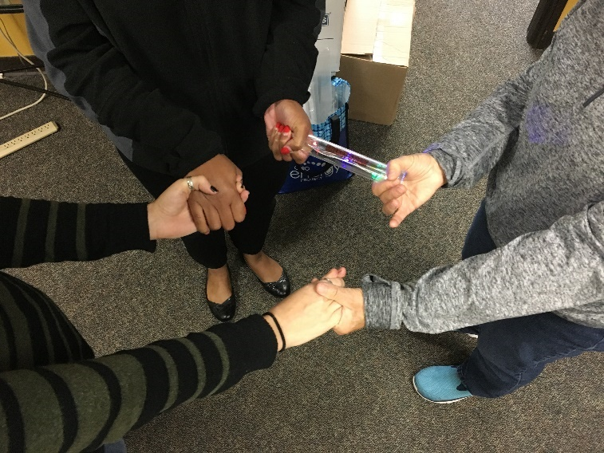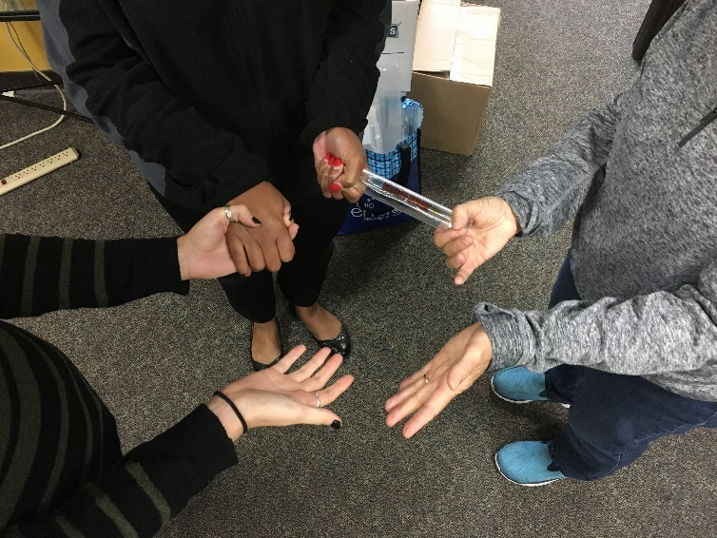
CLOSED CIRCUIT OPEN CIRCUIT WITH SWITCH
Activity #2: Electricity Conductors and Insulators
Note to Leaders: Using the same set up with your group as in Activity #1, test each sample of a conductor or insulator buy having two students hold one end of each item. Engage your entire group in the activity.
- Next we are exploring electric conductors and insulators. Any ideas what a conductor is?
A CONDUCTOR allows electrons to easily flow.

- So, what is an electric insulator?
An INSULATOR resists or prevents the flow of electricity.

- We’re going to test different materials to determine if they are insulators or conductors. Let’s first predict if we think the material is an insulator or conductor.
  - Ask students to predict if the material is an insulator or conductor. Record hypothesis on the left side of their chart.
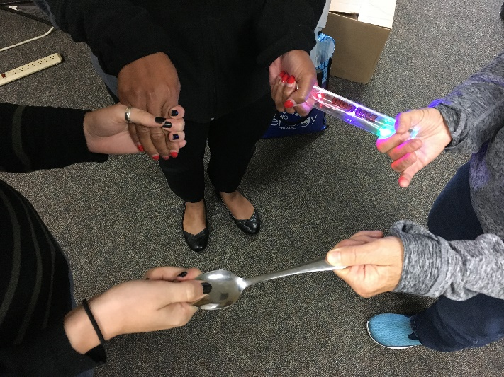
  - Test the material by placing it in the circuit with two students holding one end of each material. (see picture to left)

  - Conductors will allow the Energy Baton to light up. Insulators will resist the flow of electricity keeping the circuit open and not lighting up the Energy Baton.

  - After testing the material, put it on the chart as an insulator or conductor and have the students circle the correct answer on the right side of their chart. (see picture below)
Test each sample insulator or conductor
Place each item on the chart in the conductor or insulator column. Have the students record the correct answer in their student guidebooks.
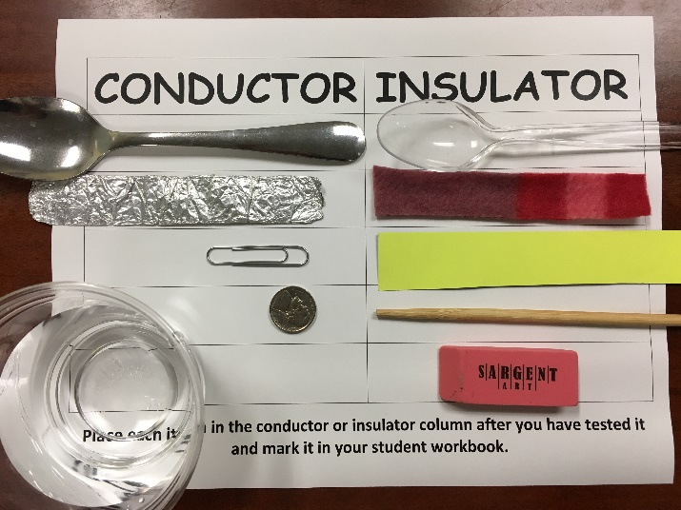
Complete Student Guidebook Questions:

- Describe why utility workers wear rubber sleeves, gloves and boots.
Rubber is a good insulator and protects the workers

- Why do lifeguards clear the pool when a thunderstorm approaches?
Water is a good conductor so you shouldn’t swim during a thunderstorm

