**SAMPLES FOR DESIGN CHALLENGES**

**Challenge 1 - Build a structure using one cube or cup as the base.**

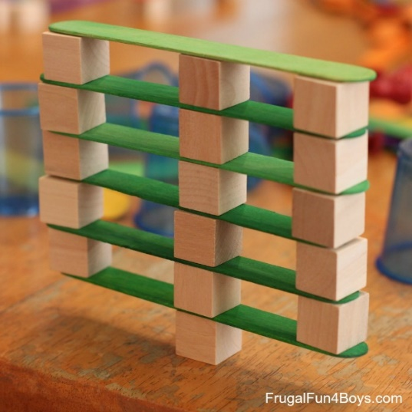 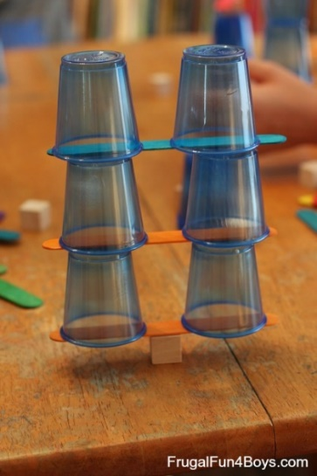

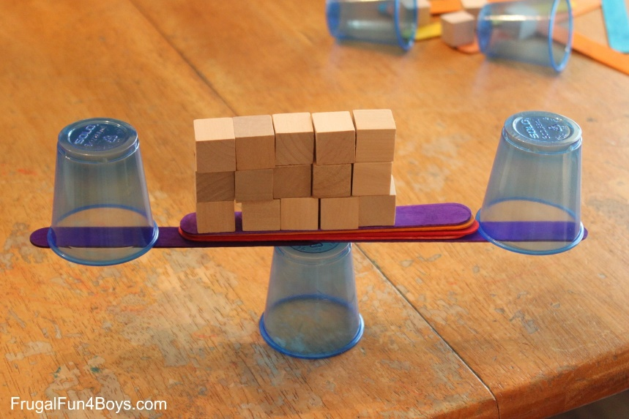 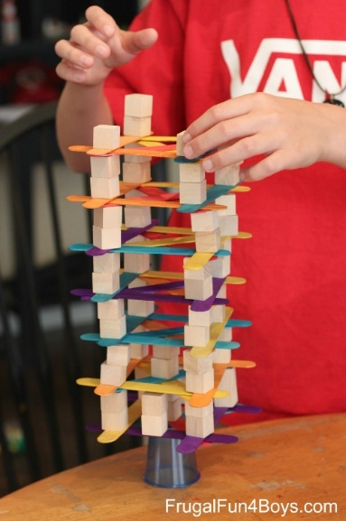

**Challenge 2:  Feats of Balance.  Make something on your structure stick out in an impressive way!**

